# Assignment 14

Screenshots of UI and database Link for task management

Link - <https://www.appsheet.com/dbs/database/F8yrVridxH4Aqh_0vjkv47?utm_source=share&utm_medium=referral&utm_campaign=databaselink>

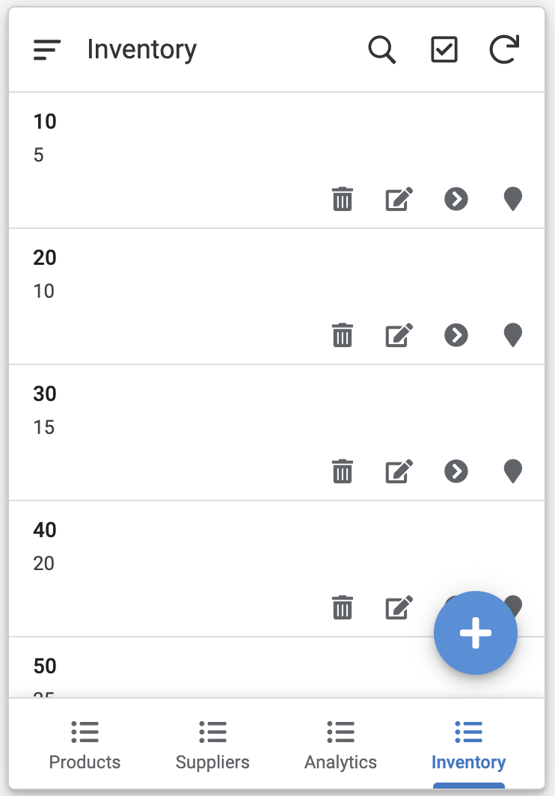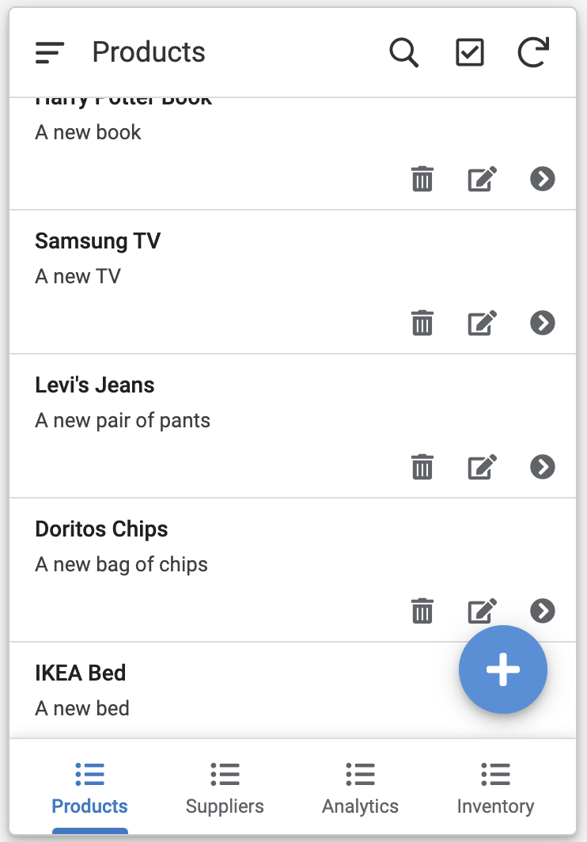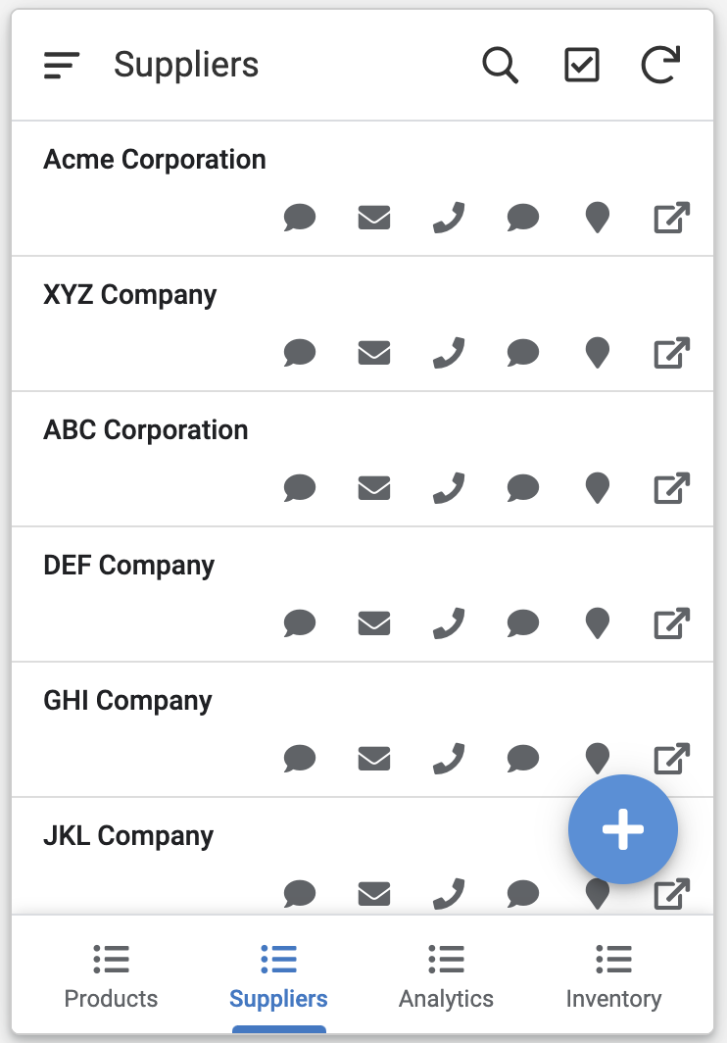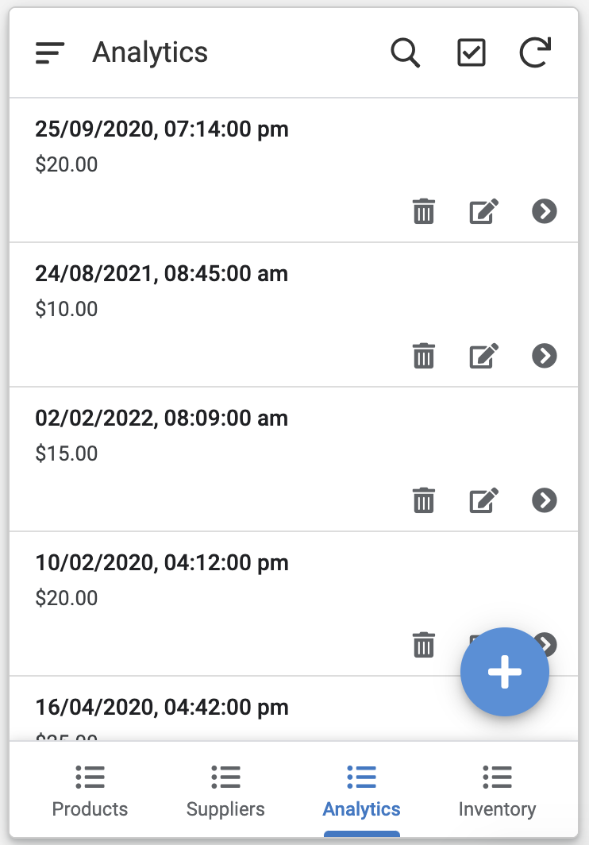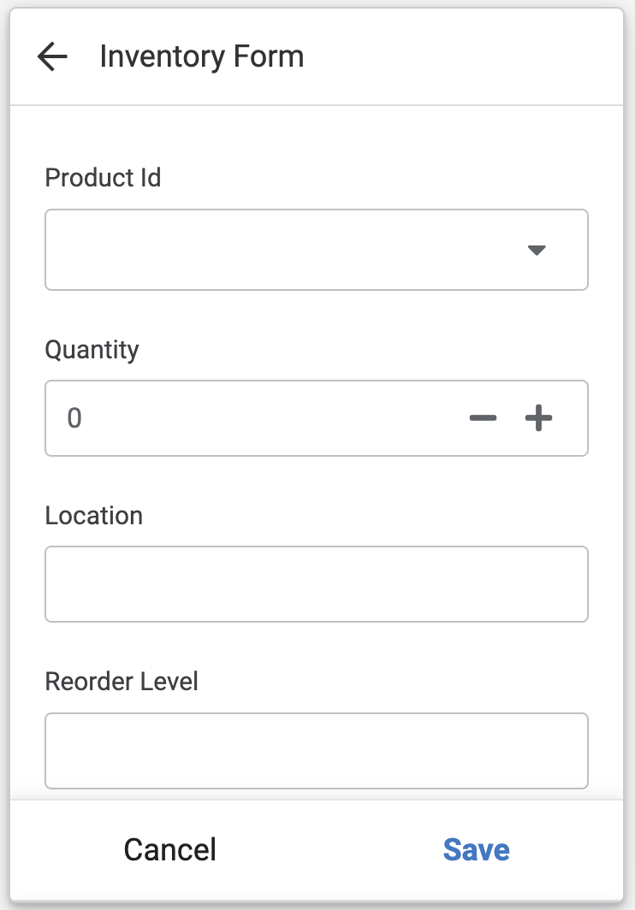

Database Screenshot -

